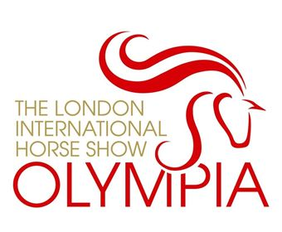

Kings Bounty Equine Practice Christmas Picture Quiz
Complete this quiz to give yourself a chance to WIN 2 top seat tickets to the Sunday Afternoon Performance at Olympia, The London International Horse Show on Sunday 23rd December.
Please fill in your answers on the answer sheet provided and return to us via email to admin@kingsbountyequine.co.uk or via post to Kings Bounty Equine Practice, Kings Bounty, Church Street, Binsted, Hampshire GU34 4NX. Alternatively, please email your answers directly to admin@kingsbountyequine.co.uk if you cannot download the answer sheet.
Please send in your answers by no later than the 30th November 2018.
The winner will be announced the first week of December!
- This is a radiograph of a stifle – what would be your diagnosis?
Clue: It is taken from a YOUNG horse …………………………………………………………………………………………………………..
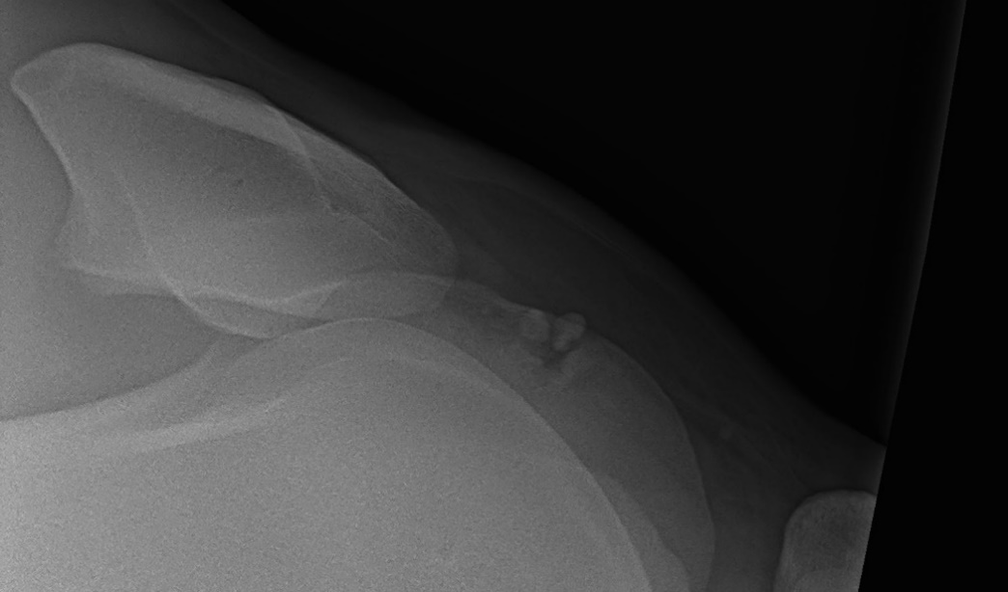

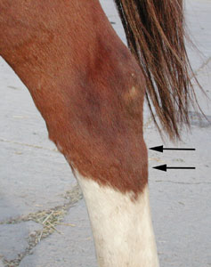
- What condition of the leg is this?
…………………………………………………………………………..

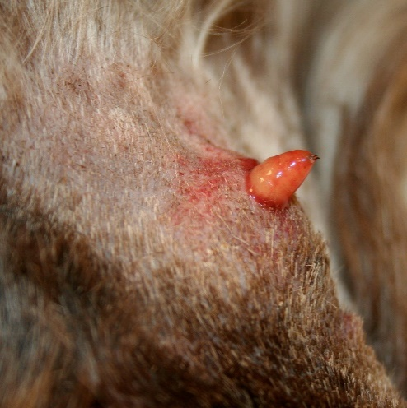
- What is this?
Clue: This is commonly seen in cattle and is a notifiable disease in Scotland.
…………………………………………………………………..

4a) What is the condition with this eye?
……………………………………………………………………………………………………………….
b) Why is there a green colour?
……………………………………………………………………………………………………………….
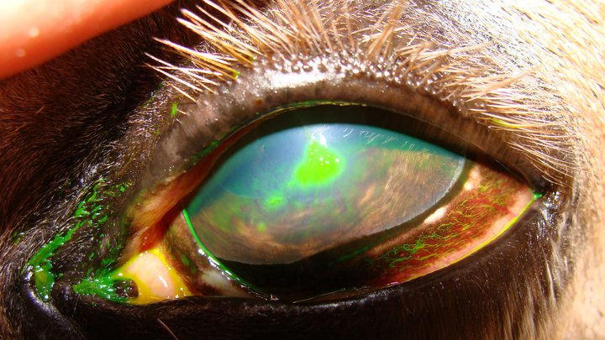

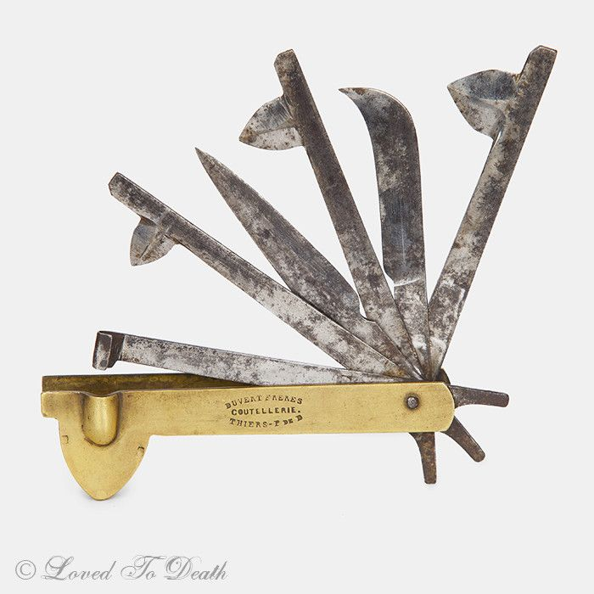
5a) What old fashioned piece of veterinary equipment is this?
…………………………………………………………………………
b) What were they used for?
…………………………………………………………………………

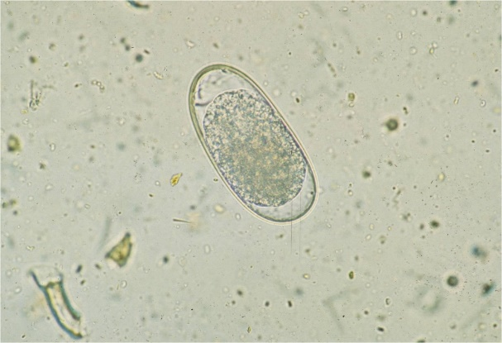
6) What is this?
Clue: We frequently look for these in horses poo samples ………………………………………………………………

7a) What do the arrows show?
……………………………………………………………………………………………………………………………
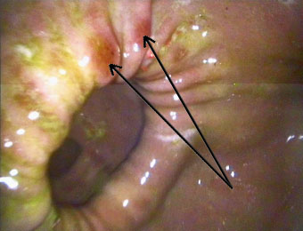

b) What is this line in the stomach called?
Clue: M_ _ _ _ P _ _ _ _ _ _ _ ………………………………………………………………………………………………………………

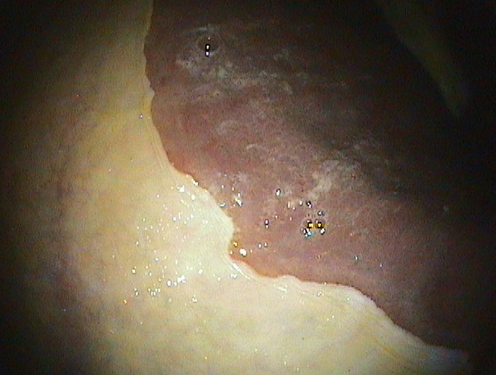

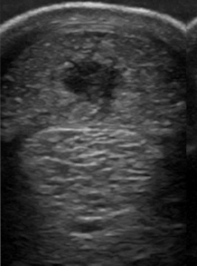
8a) What imaging technique is shown here?
…………………………………………………………………
b) What structure is involved?
Clue: It is within the lower limb ………………………………………………………………….
c) What is the problem?
…………………………………………………………………..

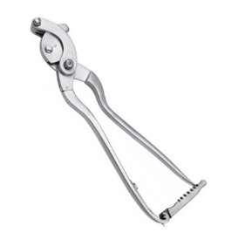
9. Name the following bits of veterinary equipment and their use in practice.
a) ………………………………………………………………….

b) ………………………………………………………

10) Name the following famous horses and their riders.

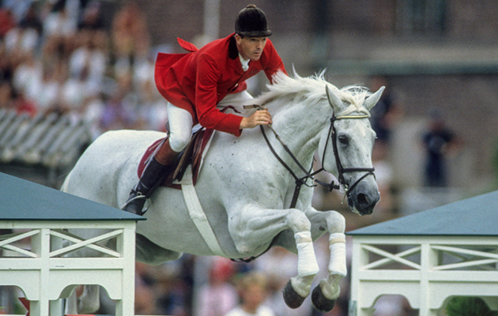
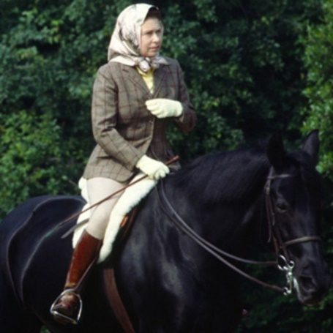
a) b)

………………………………………….. ………………………………………………………….

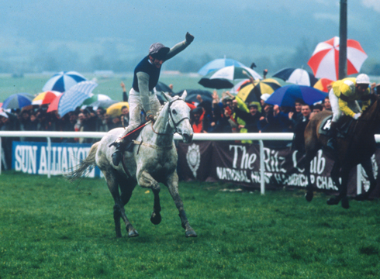
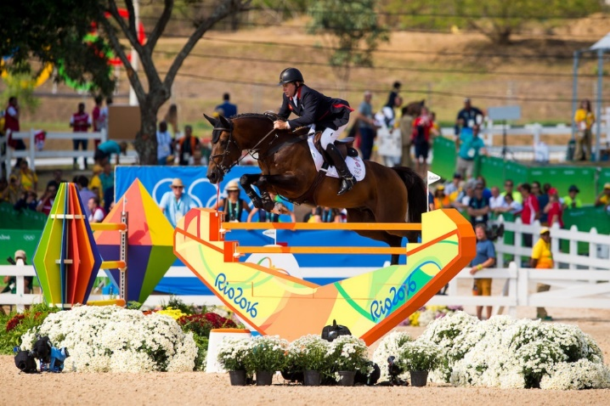
c)
d)

…………………………………………………………… ………………………………………………..
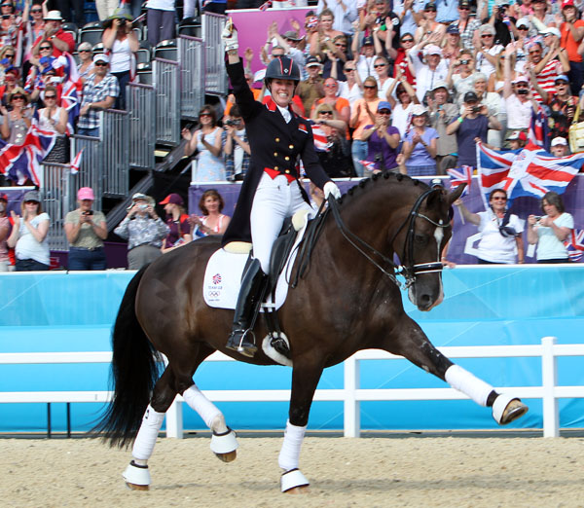
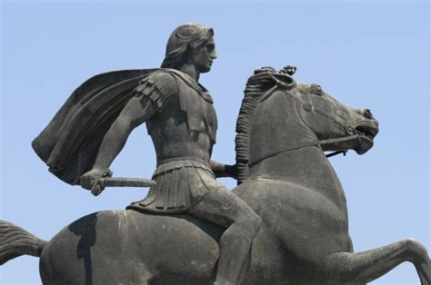
e) f)

……………………………………………………….. ……………………………………………….

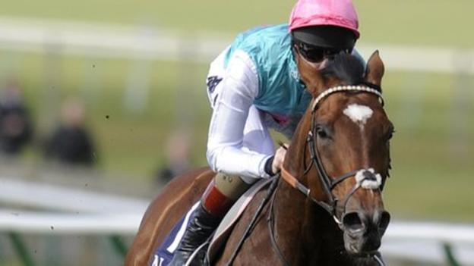
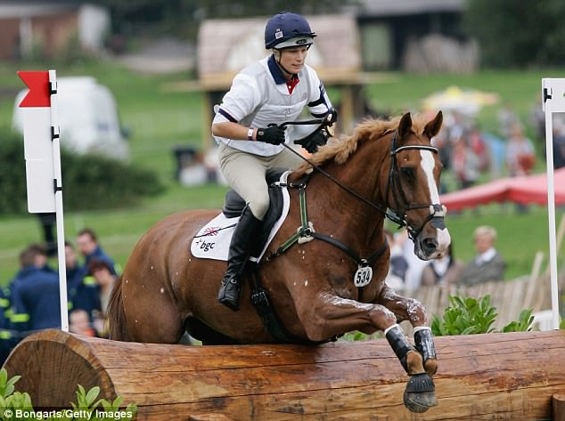
g)
h)

………………………………………………………. ……………………………………………………..

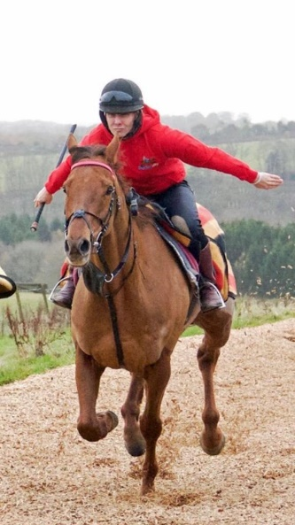
i)
……………………………………………………………………………….

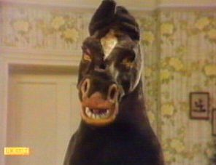
11a) What is the name of this famous horse
………………………………………………………..
b) Which TV show did the horse appear in?
………………………………………………………..

12) Can you guess which Kings Bounty Vet is which?
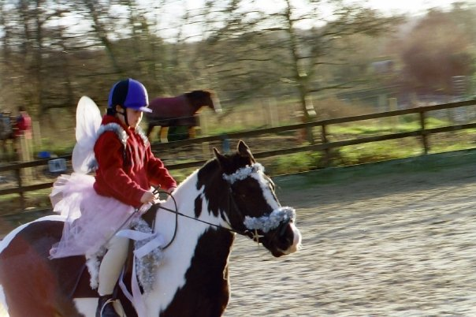
a) ………………………………………….

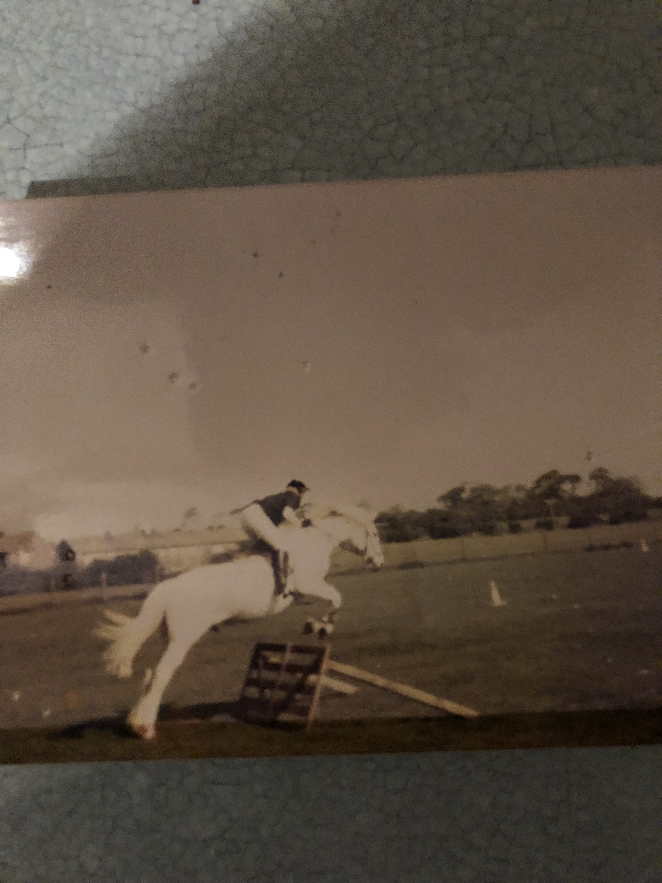
c)

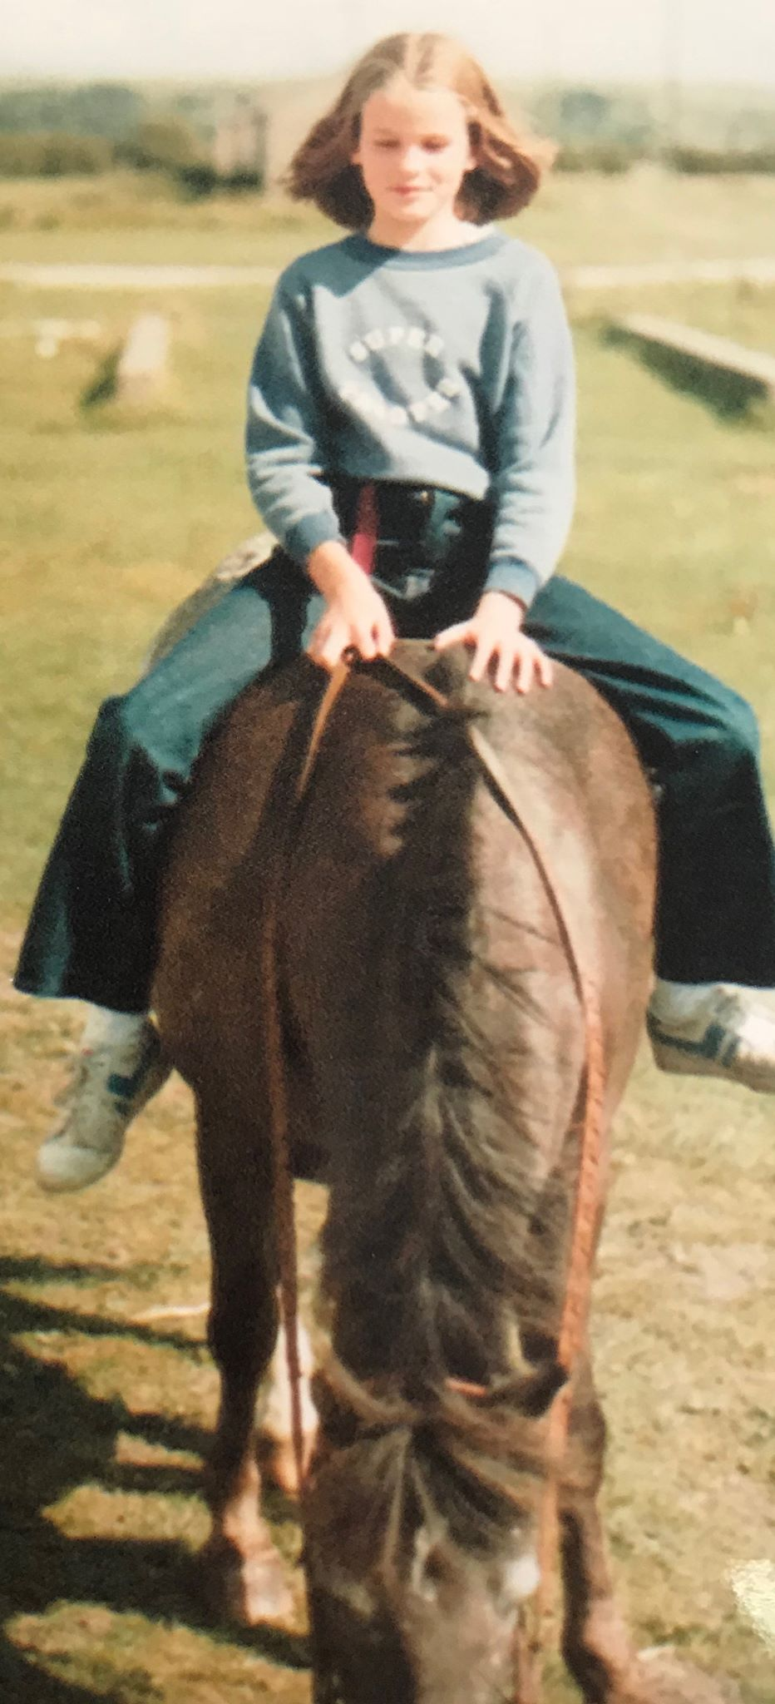
b)

………………………… …………………………………………….

GOOD LUCK!

